## **I. Introduction:**

1.1 Purpose:

The Software Requirements Specification (SRS) will provide a detailed description of the user requirements and constraints for the Hotel Management System (HMS). This SRS will enable a complete understanding of what is expected from the system to be built. A clear understanding of the system and its functionality will enable the correct software development for the end user and will be used to develop future phases of the project. From this SRS, the Hotel Management System can be designed, built and finally tested.

This SRS will be used by the system development team building the HMS. Hotel end users will be able to use this SRS as a “test” to see if the construction team has built the system according to their expectations. If it is not as expected, the end user can specify how it is not to their liking and the team will change the SRS to fit the end user's needs. Hotel managers and receptionists can also use this document to better understand the system and how to use it.

1.2 Document Conventions:

Headings Times New Roman/18 font size/Bold

Sub Headings Times New Roman/14 font size/Underline

1.3 Intended Audience and Reading Suggestions:

People who will read the project plan document will include:

- Software development team

- Project manager

- Customers

- Tester

1.4 Product Scope:

This Project Plan document will outline the scope, milestones, tasks, and schedule. That is the roadmap for project implementation and monitoring.

1.5 References:

Sommerville-Software-Engineering-10ed

## **II. Project Schedule:**

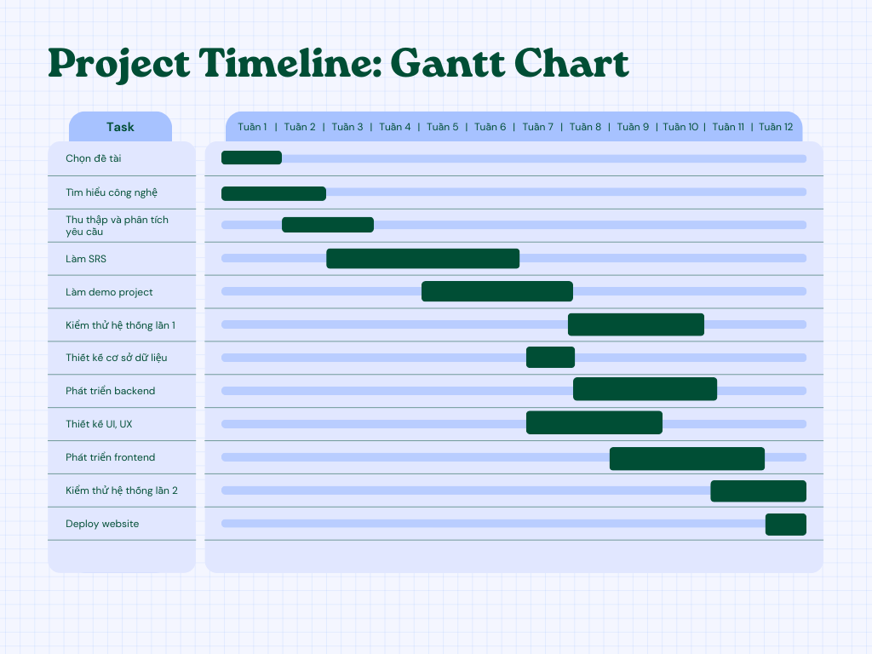

## **III. Resource Allocation:**

3.1 Software

* Development tools:

- IntelliJ IDEA Ultimate Edition (IDE)

- Visual Studio Code (Text editor)

- Git (version control system)

* Framework group:

- Spring Boot: Java framework helps develop web applications quickly and easily.

- ReactJS: JavaScript framework that helps build interactive and efficient web user interfaces.

* Database Group:

- MySQL: Popular open source database management system, used to store data for applications.

3.2 Hardware:

- Personal laptop

3.3 People:

- Hoang Dang Khai - 22028022

- Tran Duy Tuan Anh - 22028228

- Le Van Luong - 22028040

- Nguyen Duy Anh Quoc - 2202

- Vu Viet Hung - 22028124

3.4 Materials

- Documents about hotel data:

+ Room images, room videos, hotels

+ Information about amenities, services and room rates

- Legal documents:

+ Website policies and terms of use.

+ Information related to legal regulations on hotel management.

## **IV. Task Breakdown and Roles:**

|  |  |  |
| --- | --- | --- |
| Task Description | Assigned to | Estimated time |
| a) Write software requirements specification |  | 4 weeks |
| Introduction | Vũ Việt Hùng | 1 week |
| Specific requirements | Hoàng Đăng Khải  Trần Duy Tuấn Anh  Vũ Việt Hùng | 2 weeks |
| Overall description | Lê Văn Lương  Hoàng Đăng Khải  Nguyễn Duy Anh Quốc | 2 weeks |
| b) Write plan document | Vũ Việt Hùng | 1 week |
| c) Write framework report | Trần Duy Tuấn Anh | 1 week |
| c) Develop backend | Nguyễn Duy Anh Quốc  Lê Văn Lương  Hoàng Đăng Khải | 3 weeks |
| e) Build database | Hoàng Đăng Khải  Nguyễn Duy Anh Quốc | 1 weeks |
| f) Design UI, UX | Trần Duy Tuấn Anh  Vũ Việt Hùng | 3 weeks |
| g) Develop frontend | Trần Duy Tuấn Anh  Vũ Việt Hùng  Hoàng Đăng Khải | 3 weeks |
| h) Software Testing | Hoàng Đăng Khải  Lê Văn Lương  Nguyễn Duy Anh Quốc | 5 weeks |
| I) Deploy web | Hoàng Đăng Khải  Nguyễn Duy Anh Quốc | 9 days |

## **V. Communication Plan:**

Meeting schedule: (every few weeks)

- Online meeting: Sunday 8:00 p.m

- Offline meeting: 10am Tuesday

Communication tools:

- Online meeting: Discord

- Notifications and information exchange: Facebook, Messenger.

- Document storage: Google Driver

- Track work progress: Trello

**VI. Risk Assessment and Mitigation Strategies**

Risks:

- Team members have health problems.

- Impact: slows progress by 1 or 2 weeks depending on the member's health.

- Risk mitigation strategy: members keep healthy, complete work early before deadline, and proactively support each other.

**VII. Review and Approval**

## 